**INTERNET APPLICATIONS PROGRAMMING**

Headquarters: Our headquarters office is a restaurant, in which the client can make the orders. Who are processed by the WEB API. The web API processes the petition, and send some requests to the database.

Branch: Our branch is the delivery system. After an order is completed, if correct, the headquarters send the information to the delivery system, and creates a new order in the delivery database.

Both WEB APIS are connected.

* TECHNOLOGIES

For both WEB APIs we are using python programming language, using flask framework.

For both clients we are using postman to send the requests.

For both databases we are using local databases using phpMyAdmin and Xampp.

For our repository we are using GitHub.

* UML ACTIVITY DIAGRAM

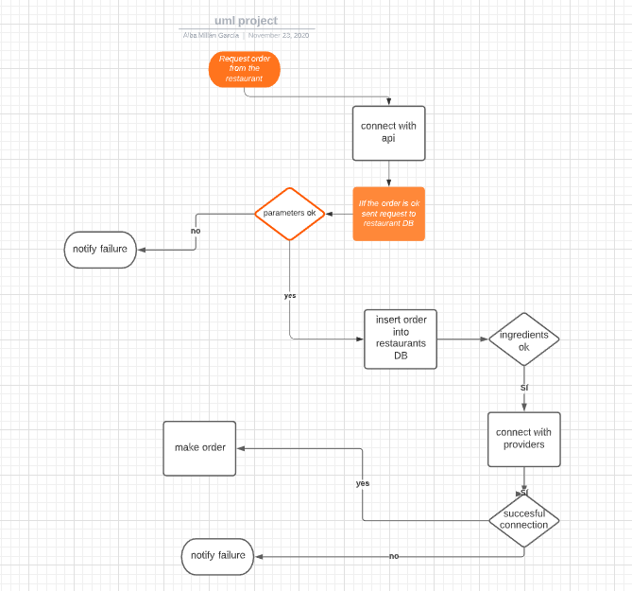

* UML DEPLOYMENT DIAGRAM

